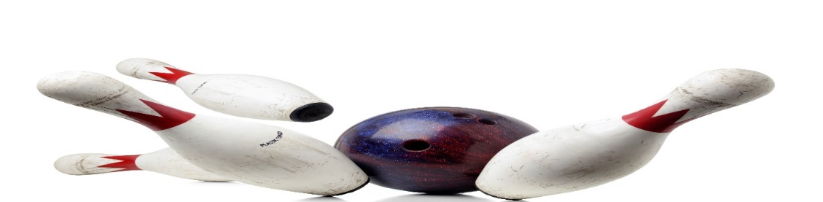
YOUTH BOWLING LEAGUE
LOOKING FOR ALL YOUTH BOWLERS, AGE 10 AND UNDER WHO WOULD LIKE TO HAVE SOME FUN AND LEARN A FEW FUNDAMENTALS OF BOWLING
SATURDAY MORNING, 10AM
THIS WILL BE AN EVERY OTHER WEEK SESSION
BOWL 2 GAMES, $10/PERSON
INCLUDES SHOES
PARENT FOR CONTACT_____________________PHONE #_____________
BOWLERS NAME__________________________AGE_________________
______________________________________________
______________________________________________
CALL OR SIGN UP NOW
MEETING SEPTEMBER 16, 2023,
EACH CHILD IN ATTENDANCE WILL RECEIVE 2 FREE GAMES THAT DAY!
SESSION WILL START SEPTEMBER 30, 2023
HOWELL BOWL-E-DROME 517-546-0820

