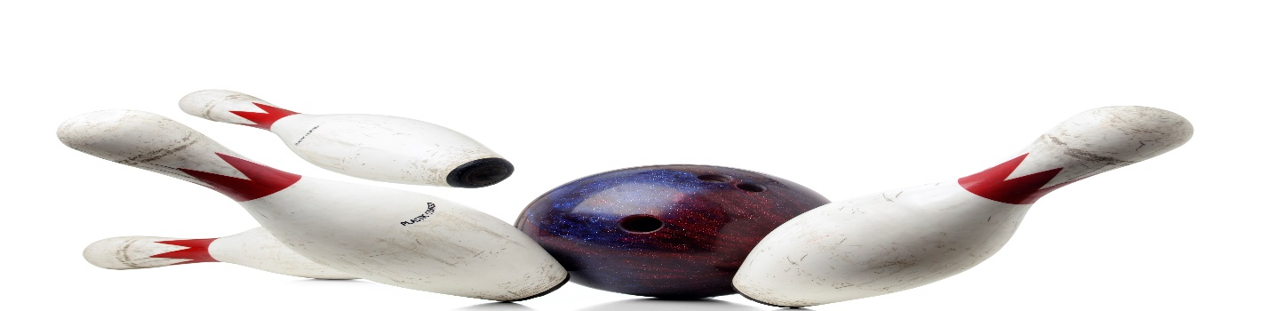
WEDNESDAY MORNING STRIKERS
LOOKING FOR 2 WOMEN TEAMS AND INDIVIDUALS
WEDNESDAY, 930AM
3 GAMES, JACKPOTS,
PRICE TO BE DETERMINED
MAIN CONTACT___________________________PHONE #_____________
TEAM MEMBERS______________________________________________
______________________________________________
______________________________________________
______________________________________________
CALL OR SIGN UP NOW
MEETING AUGUST 16, 2023, 930AM
LEAGUE START DATE TBD
HOWELL BOWL-E-DROME 517-546-0820

