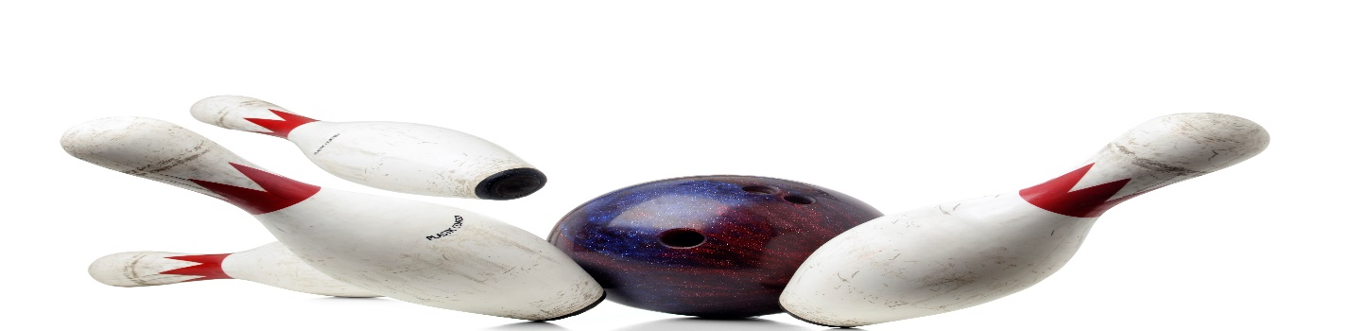
SAINTS AND SHEPHERDS
MIXED BOWLING LEAGUE
LOOKING FOR 4-PERSON TEAMS AND INDIVIDUALS
SUNDAY@ 2:15PM
3 GAMES, JACKPOTS
PRICE TO BE DETERMINED
MAIN CONTACT___________________________PHONE #_____________
TEAM MEMBERS______________________________________________
______________________________________________
______________________________________________
CALL OR SIGN UP NOW
MEETING SEPTEMBER 17, 1:30PM
LEAGUE STARTS SEPTEMBER 17, 2023
HOWELL BOWL-E-DROME 517-546-0820

