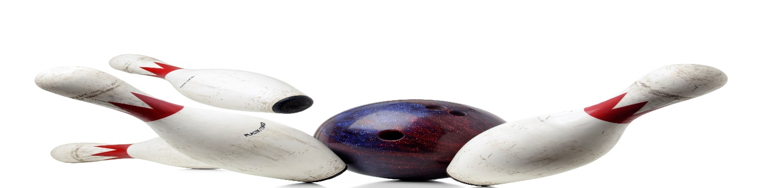
PRIME TIMERS SENIOR
MIXED BOWLING LEAGUE
LOOKING FOR 4-PERSON TEAMS AND INDIVIDUALS
FRIDAY, 1130 AM
3 GAMES, JACKPOTS
PRICE TO BE DETERMINED
MAIN CONTACT___________________________PHONE #_____________
TEAM MEMBERS______________________________________________
______________________________________________
______________________________________________
CALL OR SIGN UP NOW
MEETING AUGUST 31, 2023, 2PM
LEAGUE STARTS SEPTEMBER 8, 2023
HOWELL BOWL-E-DROME 517-546-0820

