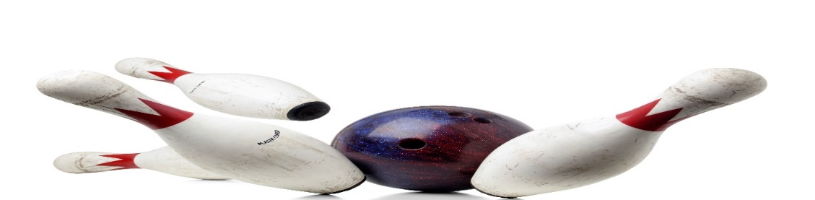
PRESCHOOL BOWLING
AGE 4 AND UNDER WHO WOULD LIKE TO HAVE SOME FUN
THURSDAY MORNING, 10AM, OR
THURSDAY AFTERNOON, 1PM
6 WEEKS STARTING SEPTEMBER 14, 2023
BOWL 2 GAMES, $12/BOWLER
INCLUDES SHOES, BUMPERS AND BALL RAMPS, IF NEEDED.
PARENT FOR CONTACT_____________________PHONE #_____________
BOWLERS NAME__________________________AGE_________________
A SNACK OF PBJ OR GRILLED CHEESE SANDWICH, MILK AND COOKIE WILL BE INCLUDED

CALL OR SIGN UP NOW
HOWELL BOWL-E-DROME 517-546-0820
