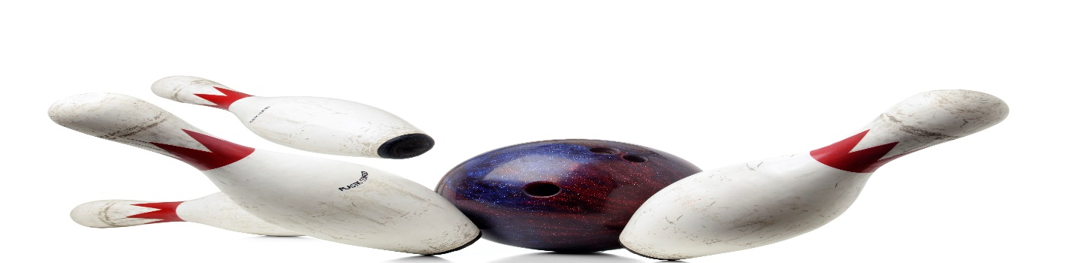
ODD CREW
MIXED BOWLING LEAGUE
LOOKING FOR 4-PERSON TEAMS, COUPLES AND INDIVIDUALS
THURSDAY, 6:45PM
3 GAMES, JACKPOTS
PRICE TO BE DETERMINED
MAIN CONTACT___________________________PHONE #_____________
TEAM MEMBERS______________________________________________
______________________________________________
______________________________________________
CALL OR SIGN UP NOW
MEETING AUGUST 17, 6:30PM
LEAGUE STARTS SEPTEMBER 7, 2023
HOWELL BOWL-E-DROME 517-546-0820

