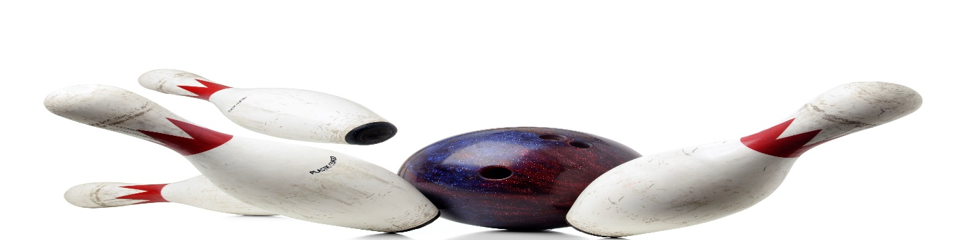
LADIES A
BOWLING LEAGUE
LOOKING FOR 4-WOMEN TEAMS AND INDIVIDUALS
WEDNESDAY@ 6:00PM
3 GAMES, JACKPOTS
WEEKLY FEE TO BE DETERMINED
MAIN CONTACT___________________________PHONE #_____________
TEAM MEMBERS______________________________________________
______________________________________________
______________________________________________
CALL OR SIGN UP NOW
MEETING AUGUST 23, 6:OOPM
LEAGUE STARTS SEPTEMBER 13, 2023
HOWELL BOWL-E-DROME 517-546-0820

