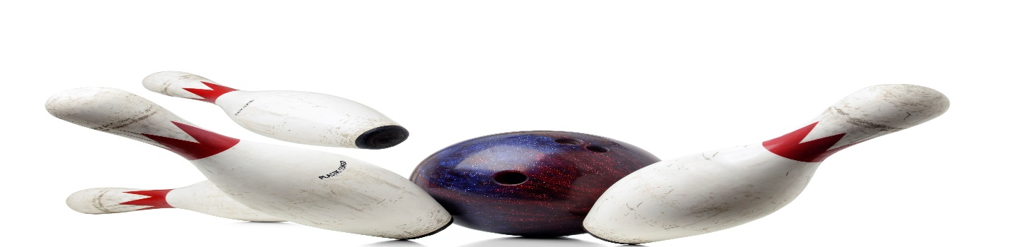
HOWELL MEN BOWLING LEAGUE
LOOKING FOR 5-MAN TEAMS AND INDIVIDUALS
MONDAY NIGHTS @ 6PM
3 GAMES, JACKPOTS, SPLIT SEASON
PRICE TO BE DETERMINED
MAIN CONTACT___________________________PHONE #_____________
TEAM MEMBERS______________________________________________
______________________________________________
______________________________________________
______________________________________________
CALL OR SIGN UP NOW
MEETING AUGUST 23, 2023, 7PM
LEAGUE STARTS SEPTEMBER 11, 2023
HOWELL BOWL-E-DROME 517-546-0820

