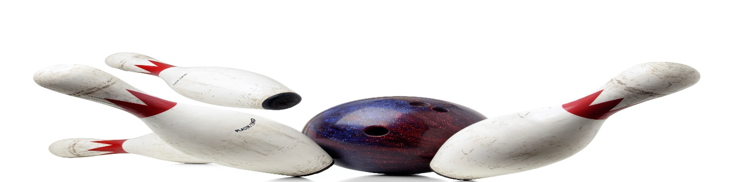
DIRTY DOZEN
MIXED BOWLING LEAGUE
LOOKING FOR 4-PERSON TEAMS AND INDIVIDUALS
SUNDAY@ 5:00PM
3 GAMES, JACKPOTS
PRICE TO BE DETERMINED
MAIN CONTACT___________________________PHONE #_____________
TEAM MEMBERS______________________________________________
______________________________________________
______________________________________________
CALL OR SIGN UP NOW
MEETING AUGUST 20, 5:OOPM
LEAGUE STARTS SEPTEMBER 10, 2023
HOWELL BOWL-E-DROME 517-546-0820

