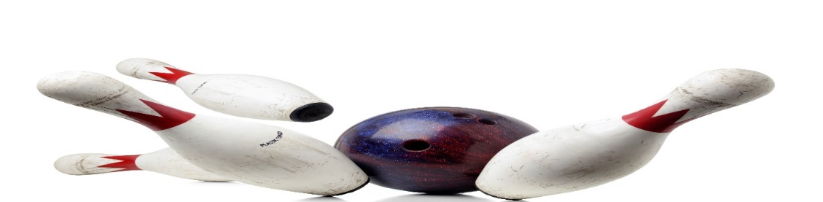
ADULT YOUTH BOWLING
YOUTH, AGES 11-18 WITH AN ADULT
SUNDAY, 12:30PM

12 WEEKS STARTING SEPTEMBER 17, 2023
BOWL 3 GAMES, $15/TEAM/ WKLY, W/$10, ONE-TIME, REGISTRATION FEE
INCLUDES SHOES
ADULT BOWLER__________________________PHONE #_____________
YOUTH BOWLER NAME____________________AGE_________________
______________________________________________
______________________________________________
CALL OR SIGN UP NOW
HOWELL BOWL-E-DROME 517-546-0820

