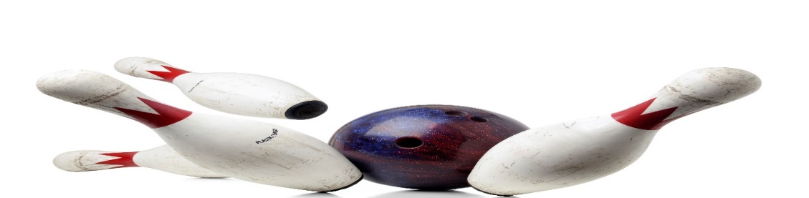
ADULT YOUTH BOWLING
YOUTH, AGES 5 - 10 WITH AN ADULT
TUESDAY, 6:30pm

12 WEEKS STARTING SEPTEMBER 19, 2023
BOWL 2 GAMES, $15/TEAM/ WKLY, W/$10, ONE-TIME, REGISTRATION FEE
INCLUDES SHOES
ADULT BOWLER__________________________PHONE #_____________
YOUTH BOWLER NAME____________________AGE_________________
______________________________________________
______________________________________________
CALL OR SIGN UP NOW
HOWELL BOWL-E-DROME 517-546-0820

